Lab Assignment: Lab 2: Air Resistance

Title Author: Misbah Ahmed Nauman

CCID: misbahah

Student ID: 1830574

Lab Partners: Arshiya, Zeeshan, Samhita and Ahkil

EN PH 131, ET23

TA: Kiril Kolevski

Date of Lab: 01/30/2024

Lab 2: Air Resistance
Question 1: (Graphs and Images)
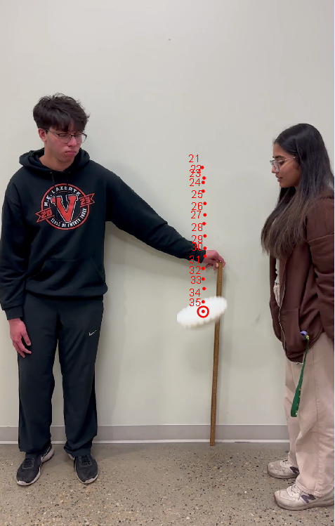

Fig 2.1: Screenshot of a frame taken when analyzing a falling stack of 20 filter sheets on the Tracker software. Meter-rule is used as a calibration stick. Tracked points of frame 21 to frame 35 are denoted by a red dot in the figure.

Table 2.1: Sample data table of a trial shown for a stack of 10 sheets of filter paper where Time is in seconds (s), Y-velocity is in meter/second (m/s), and Y-position is in meters (m). All these values were obtained by using the Tracker software where the position of the stack (assumed as a point mass) in each frame was tracked manually as shown in Fig 2.1.
Time (s) | Y-velocity (m/s) | Y-position (m)
0.000 | 0.000 | 2.297
0.017 | 0.539 | 2.283
0.033 | 0.588 | 2.279
0.050 | 1.175 | 2.263
0.067 | 1.567 | 2.240
0.083 | 1.213 | 2.211
0.102 | 1.213 | 2.198
0.118 | 1.665 | 2.168
0.135 | 1.714 | 2.142
0.152 | 1.861 | 2.111

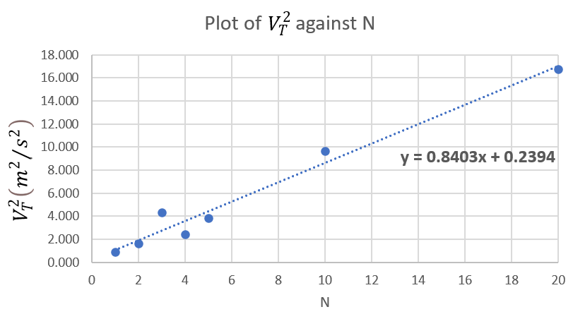
Fig 2.2: A plot of $V_{T}^{2}$ as a function of N (number of filters) with a trendline showing the results of linear fit is shown. Equation of trendline is y = 0.840x + 0.239, where the slope = (0.840 $±$ 0.06) m²/s² and the y-intercept = (0.239 $±$ 0.6) m²/s² were obtained using the LINEST function in MS Excel.
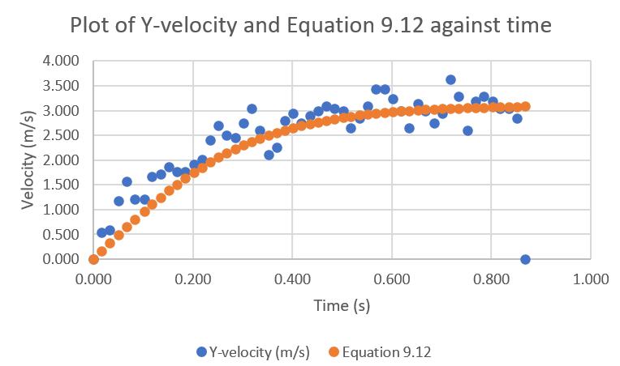
Fig 2.3: A plot of Y-velocity as a function of time denoted by a blue dot, and a plot of calculated Y-velocity (using Eq. 9.12 from the Lab Manual) as a function of time denoted by an orange dot, for N = 10 is shown. To calculate the Y-velocity (using Eq. 9.12), a terminal velocity ($V_{T}$) that produced a good agreement between Eq. 9.12 and original data was to be figured out by eyeballing where the original Y-velocity (blue dot) becomes constant. This terminal velocity was calculated to be $V_{T}$ = 3.11 m/s.

Question 2: (Calculating the Drag Coefficient)
We know that the slope of Fig 2.2. is equal to $\frac{2m_{F}g}{C_{d}Aρ}$
where,
$m_{F}$ = mass of single filter measured using balance = (1.55 $±$ 0.005) × 10⁻³ kg
g = acceleration of free fall = 9.81 m/s²
Radius measured using meter-rule = (0.1085 $±$ 0.002) m
$ΔA=\sqrt{{\left(\frac{∂A}{∂r}Δr\right)}^{2}}=\sqrt{{\left(2πr⋅Δr\right)}^{2}}=\sqrt{{\left(2π\left(0.1085\right)⋅\left(0.002\right)\right)}^{2}}$ = 0. 001 m²
A = area of cross-section = π $×$ (0.1085)² = (0.0370 $±$ 0.001) m²
$ρ$ = mass density of air = 1.29 kg/m³
slope, m = (0.840 $±$ 0.06) m²/s²
Therefore,
Error in Drag Coefficient = $ΔC_{d}=\sqrt{{\left(\frac{∂C_{d}}{∂m_{F}}⋅Δm_{F}\right)}^{2}+{\left(\frac{∂C_{d}}{∂g}Δg\right)}^{2}+{\left(\frac{∂C_{d}}{∂A}ΔA\right)}^{2}+{\left(\frac{∂C_{d}}{∂m}Δm\right)}^{2}+{\left(\frac{∂C_{d}}{∂ρ}Δρ\right)}^{2}}$= 0.06
Drag Coefficient, $C_{d}$ = $\frac{2m_{F}g}{Aρ}×\frac{1}{slope}$ = $\frac{2\left(0.00155\right)\left(9.81\right)}{\left(0.0370\right)\left(1.29\right)}×\frac{1}{0.840}$ = (0.759 $±$0.06)
Question 3:
Calculated value of the Drag Coefficient, $C_{d}$ = 0.759 is “of order unity” since it is in the range 0.3 to 3 even when considering the error.
The Y-intercept of Fig 2.2 is not consistent with the theoretical expected value of 0. A possible reason for this could be that the model we are using (Eq. 9.12) is an approximation and assumes ideal conditions. Real-world factors such as turbulence variations, non-uniform air density, or other complexities may contribute to a non-zero y-intercept.
Question 4:
For N = 10, Terminal velocity, $V_{T}$ = 3.11 m/s.
For N = 20, Terminal velocity, $V_{T}$ = 4.09 m/s.
Question 5:
References:
[1] Lab Manual EN PH 131. Edmonton: University of Alberta, Department of Physics.

Acknowledgements:
I would like to express my gratitude to my lab partners Arshiya, Zeeshan, Samhita, and Ahkil for their invaluable assistance in recording the short videos of the falling filter sheets. Special thanks to Arshiya for her guidance in using the Tracker software. Additionally, I extend my appreciation to our lab Teaching Assistant, Mr. Kiril Kolevski, for providing consistent guidance and support throughout the entire laboratory experiment.

